Clackamas community college
Assignment Contracts
Revised: November 9, 2018
Procedural Guide
clackamas Community college
assignment contracts procedural Guide
Getting started:
-Contracts must be entered in term in which they reside. i.e. start date of 3/15/17 would need to entered as a Winter Term Contract.
- Must use Capitol letters (contract #’s in lower case letters have to be handled differently in Colleague; lower case contract #’s can be problematic when bringing them in for payment.)
-Print FAC’s (Faculty Assignment Contracts) landscape and on white paper only.
OL (Overload) and DRP (Daily Rate of Pay). These are the contract type codes used for Full-Time Faculty members that perform Part-Time Faculty assignments. OL account must be 50204 and DRP 50206. Note: Please process a HR Service Desk Ticket if you do not see a part-time faculty position for a FT staff member or if you do not see the GL account code you are looking for. You will need to provide the employee name and employee number, effective date and budget code.
Safe Colleges – PT Faculty budget coding for Safe Colleges Training effective 7/1/18 is at the departmental level and at the Other Professional rate of pay. These training should commence during active term instruction and not on the summer recess, if applicable.
Colleague Faculty Assignment Contract(s) entry deadline is the 15th of each month.
2018/19 Update Highlights:
Updated screen shots throughout. Wording simplified and important info highlighted.
Reference to Datatel replaced with Colleague
Reference to contact info changed to contact HR Service Desk.
RFAL status location and definitions. - Page 6-7
Membership additions - page 9
Group definitions more clearly defined – Page 17
Appendix B Revised description of DRP – Page 18
Additions to FAQ C-1 and C2
PLEASE NOTE: It is very important to ONLY use the CTRL +ALT+ D keys when making changes to an assignment contract. Any other form of deleting will only delete what you see and not change the assignment contract itself that is connected to payroll. When using CTRL+ALT+D, in Colleague form FASC (Faculty Section Assignment) delete from left to right and in Colleague form FMBS (Faculty Membership) delete right to left.

Table of Contents
Making an Assignment Contract (Group 1 through 3) 1
Making Changes to Assignment Contracts 4
Adding Hours to an assignment contract in PA (paid status) 5
Substitutes & Docking Pay for Absence not Covered by Sick Time 5
How to View Contract Status 6
Making Group 4 and other professional Assignment contracts 7
Making Changes to Group 4 or Other Professional Assignments 11
Coaching and Directors (Group 5) 12
How to view and print a contract 14
Appendix A – Groups 15
Appendix B – Employees, Assignment Contract (AC) Types and Memberships 17
FAQ’s R

Making an Assignment Contract (Group 1 through 3)
 Note: This procedure does not allow the faculty member to be paid. Your HR/Payroll office must still process the appropriate records. However, this process is what creates the data that is used to create the stipend (pay) for the instructor by Payroll.
Step 1. Go to Faculty Section Assignment (FASC) screen, and enter the course section.
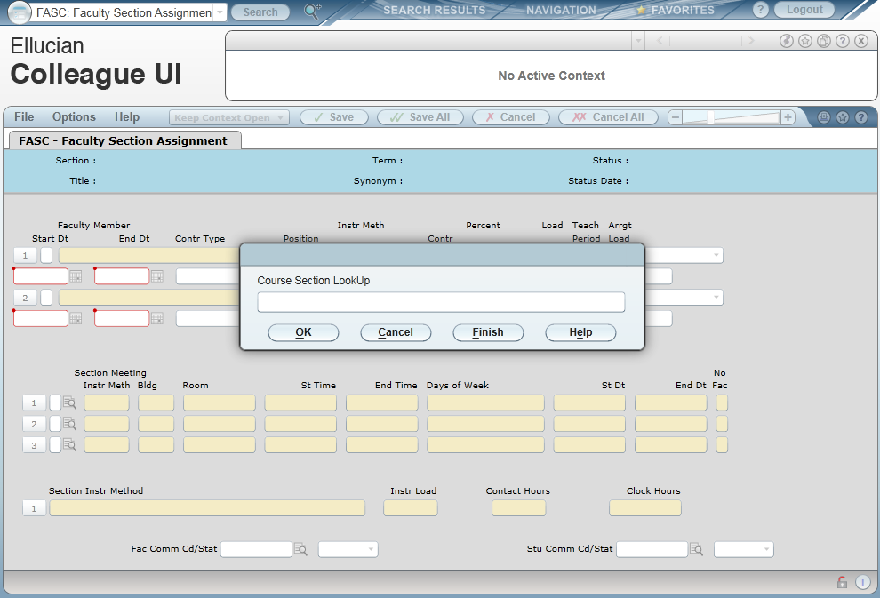Figure 1: Example of the Faculty Section Assignment (FASC) Screen
Step 2. Select the correct term, faculty member, and instructional method.
Colleague defaults the following values from the course definition (please modify dates to reflect actual time worked, if necessary):
- Start/end dates ▪ Instructional method(s)
- Workload ▪ Contact hours
You can modify any of the defaulting values, if necessary. Be aware that the group designation is determined by the instructional method. Instructional methods for:
- Group 1 are LECT, CWES, HYB, SM/WK, TC and DLO
- Group 2 are LE/LA, DLOLL and HYBLL
- Group 3 are LAB, ACT, CLIN, FIELD, PE, PRAC, DLOLB, DLCWE, and HYBLB
Step 3. Enter the appropriate contract type in the Contr Type field.
PT - Part time faculty
OL – Full time faculty assignment contracts ONLY
DRP – Must use when creating a full time faculty member to be paid daily rate of pay for non-instructional assignments (only).
The contract type is not the same as the employee type. Full time faculty will have assignments using DRP or OL.
At this point, Colleague defaults the load period which correspond to the start date of the course. You will usually change this field to reflect the correct number of hours to be paid on the FAC.
Example: Terms are defined per the Academic Calendar. For example Fall term is 09/04/16 - 12/10/16 and Winter term is 12/11/16 – 03/25/17. If the class starts 10/10/16 the default load period will be Fall term.
 Note that a term/load period begins on the Sunday after finals of the previous term and ends the Saturday after finals.
If a load period does not default, go to the load period field and enter the appropriate date(s).
Step 4. Enter the contract position for this assignment.
You will need to do a lookup for the position (…). The “funding GL” is the account code to which the expenditure will be charged. Make sure the position is using the correct code.

If there is not a position with the correct code, please contact HR Service Desk with start date and correct account code. They will add a position with the correct code to the instructor.
 Note that all positions used to pay assignment contracts must end in 50240 (instruction), 50250 (coaching), or 50265 (substitute), part time faculty wages.
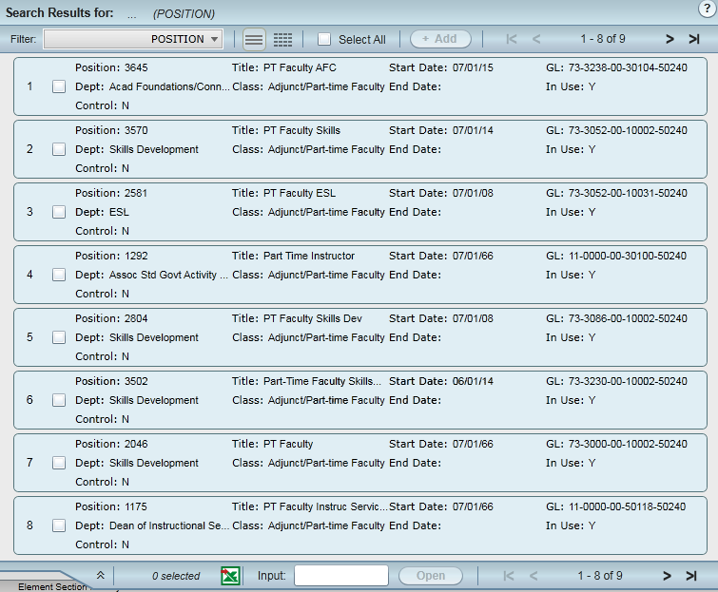Figure 2: Example of the Position LookUp Screen
Step 5. Fill in the load field with the number of contact hours the instructor is getting paid for. This should correlate with the contact hours listed at the bottom of the screen.
Step 6. Do NOT enter anything in the Contr field, it will auto-populate.
Step 7. Save the record.
Colleague has now created a pending contract and has calculated pay. This information can now be viewed by running the XCON report.
Go back to FASC screen to view the contract number. Note you may use the shift @ feature here. Figure 3: Example of the Course Section LookUp Screen
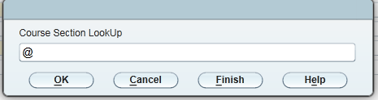
 Note that it is still possible to make changes. See section “Making Changes to Assignment Contracts” below.

Making changes to Assignment Contracts
You may make changes while the contract is in PE (pending) status and when reducing hours in a PA (paid) status.
Step 1. Access FASC
Step 2. When editing a contract, note the contract number, then delete the values using Ctrl+Alt+D (do not use the delete function button or delete whole group) in fields “Load,” "Contr Type," "Position," “Contract Number,” and “Term.” This will remove the current assignment. You must save out of the screen and then reenter FASC to proceed with the changes.
Step 3. Reenter the correct Load, change the start/end dates if necessary, Contract Type, Position and Contract Number. In the Contract Number field, type the number as previously noted. This will update the contract.
Step 4. Please verify everything is correct by running XCON (in the HR module) and comparing the totals with the PTF (Part-Time Faculty) salary schedule (Hours x Rate = Total?).
When there are changes made after a contract is in the PA (Paid) status, a warning message will appear after entering the noted contract number letting you know that you are making changes to a contract that is in the PA status.
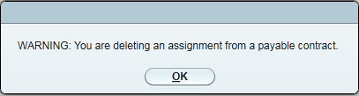
After the change has been made, the contract will be changed to an AM (Amended) status.
If your initial FAC was incorrect and you successfully updated it using the original FAC contract #, contact Payroll via Service Desk immediately.

Adding Hours to an assignment contract in PA (paid status)
When adding hours to an assignment contract in PA (paid status) follow these steps:
Step 1. Access FASC
Step 2. When adding hours to an existing contract, note the contract number, then delete the values using Ctrl+Alt+D (do not use the delete function button or delete whole group ) in fields “Load,” "Contr Type," "Position," “Contract Number,” and "Term." Do not save out of the screen proceed directly to step 3.
Step 3. Reenter the Load (only the number of hours to be paid, do not include the hours from the original contract), change the start/end dates if necessary, Contract Type, and Position. In the Contract Number field, type the number as previously noted, omitting the dash and add the letter (A, B, C, etc.) on the end. This will create a new contract.
Step 4. Please verify everything is correct by running XCON (in the HR module) and comparing the totals with the PTF (Part-Time Faculty) salary schedule (Hours x Rate = Total?).

Substitutes & Docking Pay for Absence not Covered by Sick Time
If you unsure if sick leave applies and/or is available to the employee. Please process an HR Service Desk ticket.
With group 1 through 3, if an instructor misses time that isn’t covered by their sick time, the original assignment contract needs to be changed. Proceed with the process for MAKING CHANGES TO ASSIGNMENT CONTRACTS. (Note: If the system does not allow you to use the same contract number, you must inform payroll of the old and new number to prevent double payment). Print the contract for the new assignment with XCON, and note on the contract the original contract number that this is modifying. The contract then needs to be taken to Payroll. Let Payroll know as soon as possible that this process is/has happened.
If the assignment hasn’t been made payable, delete the original assignment, create the modified assignment, and process normally.
If a substitute needs to be paid for covering a portion of the assignment, follow these steps:
Step 1. Access FASC
Step 2. Enter the course section lookup.
Step 3. On the next available line, click the line number and search for the substitute instructor.
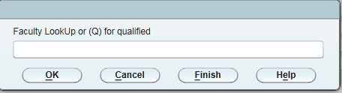
 Note: the substitute must have the same position as the original instructor.
Step 4. Enter the Load, Start/End dates (actual date(s)), Contract Type, and Position. The Contract Number will autofill.
This process can also be done on FMBS using the membership code applicable. See GROUP OP Acronyms ACSL, ACSLL and ACSLB. Page 9. Be sure to use the Course Section name in comments.

How to View Contract Status
The RFAL report has four criteria that you can mix and match to get the data you want, the assignment contract status, type, contract number or the faculty member(s).
Step 1. Access the RFAL screen in the HR module.
Step 2. Use the look up field to populate the load period field for the timeframe you want to report on.
Step 3. Populate the “Print Asgmt Contract Details” with an “Y”.
Step 4. If you want to use status as a criteria, in the Assignment Contract Statuses field enter the statuses that you want to view. You can also do this for assignment contract types.
 Note: When running this report by status only, you will receive information on every department.
Step 5. If you only want to view contracts for a particular department, enter each contract number in the field labeled Assignment Contract Number. Department is determined by the instructor’s position. It is possible to have multiple contracts within one department, if the position is set up as a separate department. To view the contract number, go into FASC on an assignment which has been created and see what is populated in the Contr field.
Step 6. If you want to use the faculty members as a criteria, in the faculty member’s field enter the faculty that you would like to view.

Contract Status
PE - Pending (not brought into payroll) - All changes allowed
Examples of a contract in this status: An original contract and/or a pending contract addendum (a contract for additional hours using the alpha sequence).

PA - Contract with Pay (brought into payroll) –Changes require call/email to Payroll

AM – Amended - The result of an amended (corrected) or addendum (added to) the last contract processed. – Information only no action required.

See parameter screen and result sample page 7
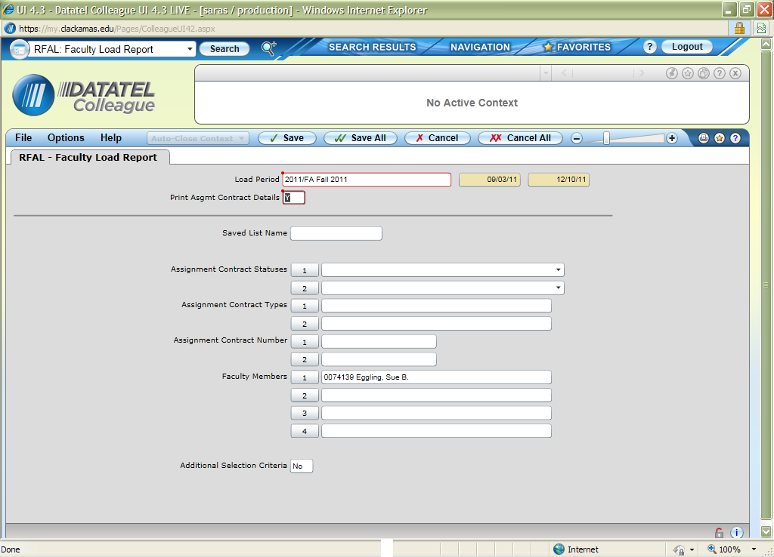
Figure 4: Example of RFAL Parameter Screen
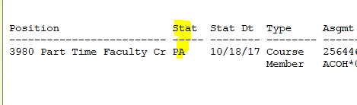

Making Group 4 and other professional Assignment contracts
In FMBS the items once located in Group 4, per the bargaining agreement, have been split between Group 4 and Other Professional Assignments (OP). When developing an assignment in FMBS it is important that you use the appropriate code below. Please do not group items within codes because this may affect the calculation of the assignment. You do not have to create separate FACs only choose the appropriate codes for the FAC.
Group OP | Acronyms |  |  | Group 4 |  |  | Acronyms
ACCBE | Challenge Exam, AC
ACCD | Curriculum Development, AC |  |  | ACCOU |  |  | Counseling
ACCEO | Community Ed other Prof./ELC Pay |  |  | ACLIB |  |  | Library Services
ACCPL | Credit for Prior Learning, AC |  |  | ACPCS |  |  | Practicum Supervision
ACCUR | Curriculum Committee, AC |  |  | ACPM |  |  | Project Management
ACDS | Distance Learning Com, AC
ACDIV | Diversity Committee, AC
ACEMC | Emt Coordinator, AC
ACEMF | Emt Proctor Full Day, AC
ACEMH | Emt Proctor Half Day, AC
ACINF | Information Resources Com, AC
ACINS | Instrct. Stand & Pract Com, AC
ACMET | Meetings, AC
ACOH | Office Hours, AC
ACOTH | Other Noninstructional, AC
ACPCC | Prep, Class Cancelled, AC
ACSEC | Campus Security Committee, AC
ACSL | Sub Pay Lecture Rate
ACSLB | Sub Pay Lab Rate
ACSLL | Sub Pay Lecture Lab Rate
ACSTF | Staff Development Committee, AC
ACUSE | Campus Use & Development Com,AC
ACWL | Non-Acad Worksp Lab
ACWLB | Non-Acad Worksp Lect/Lab
ACWLC | Non-Acad Worksp Lecture
Step 1. Access the Faculty Memberships screen (FMBS).
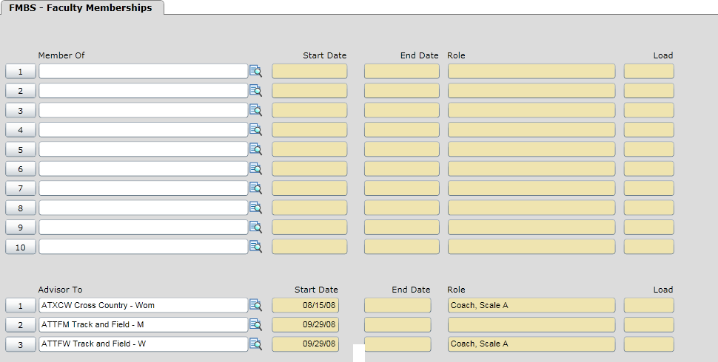
Figure 5: Example of FMBS Screen
Step 2. Enter the appropriate faculty member.
Step 3. In the Member Of field enter "..."
Step 4. Select the appropriate Organization code per Code table stated above. In the example used here for office hours, ACOH (Assignment Contract Office Hours) is chosen.
Step 5. When doing this the Faculty Membership Detail (XFMD) screen will appear.
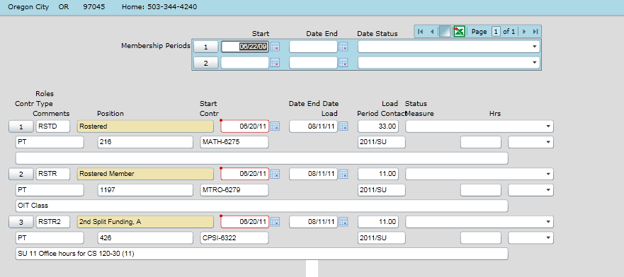
Figure 6: Example of XFMD Screen
Step 6. In the Membership Periods Start Date field, if there is not already a date there, enter the first date they are working (do not enter an end date.)
Step 7. In the Roles field enter "..." and select the option RSTR (Rostered Member). Note when developing a contract in the same term for the same employee you will need to use RSTR1, RSTR2, etc.
Step 8. Enter the start and end dates of the load they are teaching for the office hours. Be sure the start date is in the correct term/load period you want it assigned to.
Step 9. Enter the total number of contact hours they are getting paid for in the "Load" field. One office hour a week for a full term would be a load of 11. Two office hours a week for a full term would be a load of 22, etc.
Step 10. In the "Contr Type" enter "..." and select the appropriate option.
Step 11. In the position field enter "..." and select the appropriate position.
Step 12. In the load period enter "..." and select the appropriate term.
Step 13. In the comments field you can add some descriptive text. This is optional except for the Campus Organization of Other Non-instructional (ACOTH). The comments are mandatory in that case. Also, once you create the comments you can’t change or erase them without deleting the whole group.
Step 14. When you save out of XFMD, the contract number will populate. For faculty who teach in more than one department, you will need this number in order to print only assignments for the faculty members that are tied to your department.
Step 15. Click the “Save” button twice.
Step 16. If this is done after the contract is in the PA status, refer to “Making Changes to Non-Instructional Assignments” and complete steps 1-4.
Step 17. If the instructor already has office hours assigned and needs additional hours, if it’s for the same time period and position use Ctrl + Alt +D to erase the contract type, position, contract and load period and re-enter the info with the updated load. If the instructor is to be paid from a different position (different GL account) for the same time period (an instructor whose office hours are paid by two departments because they teach in both,) use the RSTR1- RSTR3 role and set the instructor up following the above steps 1 through 13.

Making Changes to Group 4 or Other Professional Assignment
It is okay to make as many changes as you want while the contract is in the PE (pending) status. However, if you have already created a non-instructional assignment through XFMD, you will need to follow these steps:
Step 1. Access FMBS and then XFMD for the appropriate Campus Organization.
Step 2. Delete the values in fields "Load," "Contract#," “Term,” “Position#,” “Contract Type” and Load Period, if needed. You will need to use Ctrl, Alt+ D to delete these values. This will remove the current assignment. Save out.
Step 3. Return by using the Shift @and begin with a new RSTR. i.e. RSTR1, reenter and or change the "Load," Load Period, if needed”, Contract Type," “Position,” and previous Contract #. Save all the way out. Process HR Service Desk ticket, if in PA (Paid) status.

Step 4. You can verify everything is correct by running XCON (in the HR module) and comparing the totals with the PTF (Part-Time Faculty) salary schedule (Hours x Rate = Total?).
When there are changes made after a contract is in the PA (Paid) status, a warning message will appear letting you know that you are making changes to a contract that is in the payable (PA) status.
After the change has been made, the contract will be changed to an AM (Amended) status.
If you are making changes to a contract that puts it in an amended status, contact Payroll via email ASAP and alert them to these changes.

Adding Hours to an assignment contract in PA (paid status)
When adding hours to an assignment contract in PA (paid status) follow these steps:
Step 1. Access FMBS
Step 2. When adding hours to an existing contract, note the contract number of the last FMBS in the current term. Enter data using the next RSTR#.
Step 3. Enter the Load (only the number of hours to be paid, do not include the hours from the original contract), change the start/end dates if necessary, Contract Type, and Position. In the Contract Number field, type the number as previously noted, omitting the dash and add the letter (A, B, C, etc.) on the end. This will create a new contract.
Step 4. Please verify everything is correct by running XCON (in the HR module) and comparing the totals with the PTF (Part-Time Faculty) salary schedule (Hours x Rate = Total?).

Coaching and Directors (Group 5)
This process is very similar to Non-Instructional Assignments, Group 4.
Step 1. Access FMBS.
Step 2. Enter the appropriate faculty member.
Step 3. In the Advisor To field enter "..."
Step 4. Select the correct Campus Organization. (Say ATBB for Baseball.)
Step 5. The FAOA screen will appear.
Figure 7: Example of FMBS using the Advisor Section

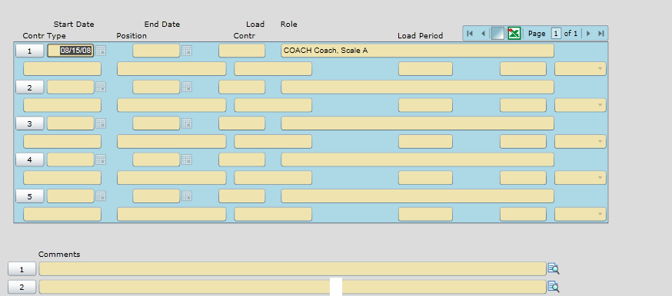
Figure 8: Example of FAOA Screen
Step 6. Enter the start and end date of the assignment. (Be sure that the start date is within the term/load period you want it assigned to.)
Step 7. Enter any load hours that would apply to dues work load. The load does not affect the amount paid to the employee.
Step 8. Do a lookup in the role field and select the appropriate role. Notice in the description the pay scale of the group 5 role.
Step 9. Fill in the Contract Type, Position and Load period and save out of the screen.
Step 10. For faculty who teach in more than one department, note the contract number. You will need this number in order to print only assignments tied to your department.

How to view and print a contract
The XCON report has four criteria that you can mix and match to get the data you want, the assignment contract status, type, contract number or the faculty member(s).
Step 1. Access the XCON screen in the HR module.
Step 2. Use the look up field to populate the load period field for the timeframe you want to report on.
Step 3. Populate the “Print Asgmt Contract Details” with an “Y”.
Step 4. Choose your criteria i.e. Contract Number. Hit “Save” 2 times.
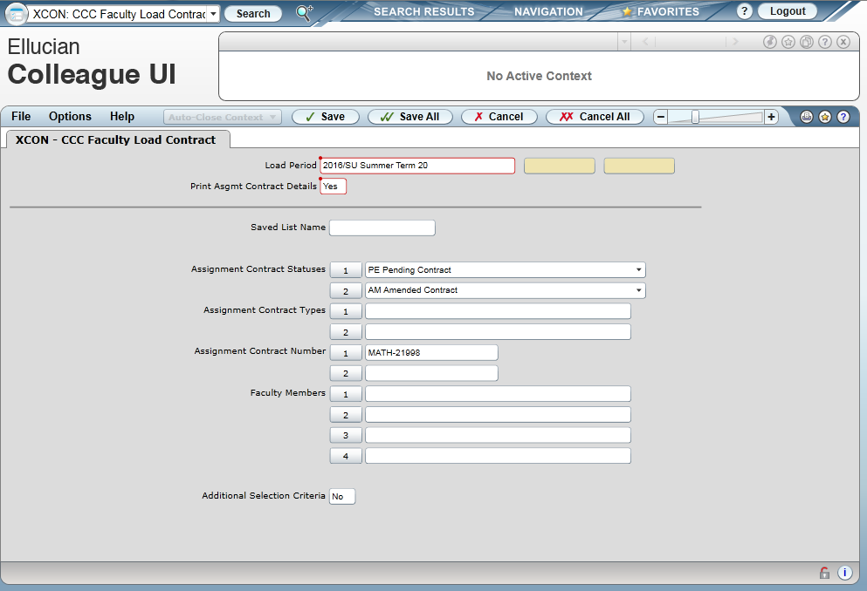

Change output device to “H.” Hit “Save” 2 times.
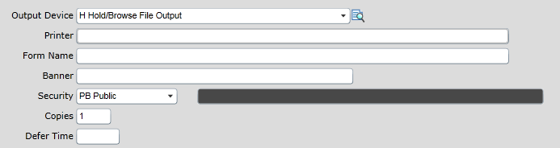
Export to PDF, choose the landscape orientation, and create PDF.
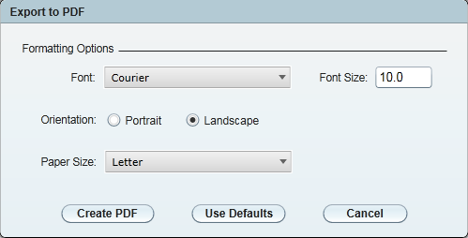
When printing, be sure to use the “fit” option so all data is captured.
 Note: If you want to use status as a criteria, in the Assignment Contract Statuses field enter the statuses that you want to view. You can also do this for assignment contract types.
 Warning: When running this report by status only, you will receive information on every department.
Step 5. If you only want to print contracts for particular department, enter each contract number here. If you do not specify a contract number for a faculty working in more than one department, a separate contract will print for each department. Department is determined by the instructor’s position. It is possible to have multiple contracts within one department, if the position is set up as a separate department. To view the contract number, go into FASC on an assignment which has been created and see what is populated in the Contr field.
Step 6. If you want to use the faculty members as a criteria, in the faculty member’s field enter the faculty that you would like to view.

Appendix A – Groups
APPENDIX A - GROUPS
 | Level
 | 1 | 2 | 3 | 4 | 5
Group 1:
Lecture courses
Group 2:
Lecture/lab courses
Group 3:
Lab courses
Group 4:
Clinical Supervision, Counselors, Librarians
Other Professional Assignments: Challenge Exams, Curriculum Development (PT Faculty only), office hours, meetings, Safe Colleges and other non-instructional time.
Group 5:
Student Activities Schedule
Scale A
Head Coaches: Baseball, Softball, Soccer, Volleyball, Wrestling, Men’s' & Women’s’ Basketball and Track
Directors: Drama, Jazz Ensemble, Forensics
Scale B
Director: Swing Choir
Scale C
Head Coach: Cross Country
Intramurals-Asst. Coaches: Baseball, Softball, Soccer, Volleyball, Wrestling, Men’s & Women’s Basketball and Track
Scale D
Director: Pep Band

Appendix B – Employees, Assignment Contract (AC) Types and Memberships

EMPLOYEES, ASSIGNMENT CONTRACT (AC) TYPES, AND MEMBERSHIPS
Type of  Employee | Work | Notes | AC  Type | Account
FT faculty | Non-instructional work and Curriculum Development, with the exception of *office hours beyond the individual’s 175-day contract. Confirm accuracy of using DRP rate with Department Dean, if needed | Per Bargaining Agreement | DRP | Faculty,  50206
FT faculty | Instructional assignments, in excess of the individual’s normal teaching load. |  | OL | Faculty,  50204
PT faculty | All work (groups 1-5) | Never use for FT assignment contracts | PT | Faculty, part time  50240-50265
Classified | Courses (groups 1-3) |  | PT | Faculty, part time  50240-50265
*Office Hours – Class prep, individual student contact.

FAQ’s
- Will instructors be paid by credit or clock hours or something else?
Salary Groups 1-4 and C are paid by contact hours entered into the load field on FASC. Group 5 is a specific amount for all work performed.
- How do we show office hours? Substitutes? Special projects?
FMBS and XFMD will be used for office hours and possibly for special projects. Substitutes will be paid as described in the section titled “Substitutes & Docking Pay for Absence Not Covered by Sick Time”.
- Who will input the info on the instructor's teaching load?
The person who creates the course section will input the contact hours for the instructor’s load.
- What if an instructor is paid out of more than one account?
They will have to be assigned a position with the proper funding from all the applicable accounts.
- Will there be a window for people to input changes? If there is a change, who will make it?
The assignment can be modified given the processes outlined in the sections “Making Changes to Assignment Contracts” and “Making Changes to Non-Instructional Assignments”. These changes can be done up until Payroll runs CLPS. At the point Payroll runs CLPS a payable stipend is created. If the assignment is modified after that, putting it into an amended status, Payroll will have to be notified so they can change/reissue the stipend.
Either the Dean’s Assistants or the Department Secretaries can make the change.
- What about classes who have instructors attached but are never paid (ex: ACC classes)?
Enter the instructor on FASC but don’t link the assignment to make an actual contract.
- What about classes that have more than one instructor?
Enter them on the FASC screen with the load split as necessary amongst the Faculty to cover the contact hours for the class.
- What if a class is cancelled?
The employee must be paid at the class rate for any time met with the class. The employee must be paid for preparation at the OP rate for classes of (3) or more credits. See Part-Time Faculty Agreement for complete details. IMPORTANT: DO NOT CANCEL CLASS WITH SCHEDULING UNTIL CONTRACTED IS AMMENDED.
- When choosing a position, do you only get one choice?
Yes, you may only choose one position number per assignment, so if you are in need of a position with more then one funding source, please contact HR Service Desk.
- Can you have Dept. Chair as instructor and not get paid?
Yes. You can have an instructor with zero load or with assignment type of FT.
- If FT faculty is in overload and then the section is cancelled, what is the process?
Delete the overload (OL) assignment and send an email to payroll.
- When we build sections, do we need to put in FT faculty loads?
It would be beneficial to input load for FT faculty, but not necessary for now.
- Will we need signatures?
You only need to obtain signatures from the department chair and/or dean. Not from the instructor. Please provide a copy for the instructor’s records.
13. When is it necessary or not necessary to contact Payroll?
When a FAC (Faculty Assignment Contract) is in a PE (Pending Status)
- All changes allowed – No contract required
- Additions can be added to the original contract # (No letters)

When a FAC (Faculty Assignment Contract) is in a PA (Paid Status)
-Reduction and budget code corrections – Requires Service Desk ticket to Payroll.
-Additions entered using letters – No contact required.
If you have additional questions, please contact Payroll by submitting a HR Service Desk ticket via Service Desk. Thank you.

DLOLL and HYBLL are new instructional methods indicating lecture/lab versions of HYB and DLO respectively.
DLOLB, DLCWE, and HYBLB are new instructional methods indicating lab versions of DLO, CWES and HYB respectively.
The reason for doing this is because the calculation for pay has already been computed and deleting and reentering this information recalculates the pay.

