ITS Remote Access Policy and Support

Table of Contents
Purpose
Scope
Approval Process
Remote Equipment Policy
Desktop Workstations
Laptops
Laptop Release Schedule
Personal Devices
Service Request
Laptop/Desktop
Procedures for Connecting Remotely
Direct Access
VDI / Virtual Desktop
Connect using the VMware Horizon Client
ITS Remote Support

Purpose
The purpose of this document is to define the structure and support of Remote Access Services (RAS) for faculty and staff of Clackamas Community College (CCC/college).

Scope
The framework in this document applies to any device owned and managed by the college that is used to remotely connect to any college computer, server, network, application or entity.

Approval Process
In accordance with existing college policy, any remote work time must be initially approved and reported to the end user’s direct supervisor before requesting any ITS services.

Remote Equipment Policy
All devices/equipment remain the property of CCC and will be returned to the college as the situation allows or as the existing remote work agreement is terminated for any reason. Equipment should be returned in working order, and no additional resources will be deployed to a user until all checked-out equipment is returned and accounted for.

Desktop Workstations
Desktop can be taken home if validated through the approval process. End users will be allowed to disassemble, pack and reassemble workstations, but in doing so accepts responsibility for any damages. Users who do not want to accept damages are encouraged to wait on the arrival of new laptops.

Laptops
New laptops have been ordered and will be issued as soon as they arrive and are configured. They will include a docking station and are designed to replace your existing workstation for those who don’t have laptops today. In order to receive your new laptop and docking station, your desktop must be turned in first, in working condition.

Laptop Release Schedule
New laptops will be released with priority given to those who have a direct impact to the student learning experience, as defined by Executive Leadership. We anticipate laptops arriving week of 03/30/2020 and the first group of laptops being ready within 24 hours.

Personal Devices
CCC does not provide support for personal devices. No personal device should be used to access CCC resources without prior authorization by IT Leadership.

Service Request

Laptop/Desktop
After supervisor approval is granted to work remotely, an Equipment Control Form (to be distributed) must be completed for each laptop/desktop that will be used off of college grounds. The form should be completed by the end user before being signed by the approving supervisor- Supervisor approval indicates that ITS can proceed with provisioning services for the listed device.
The Service Desk ticketing system can be found here:
https://clackamas.teamdynamix.com/TDClient/1853/Portal/Home/?ToUrl=

Select the Information Technology button, noting the instructions to submit a ticket to the left. Click “Submit an ITS Ticket” found here:
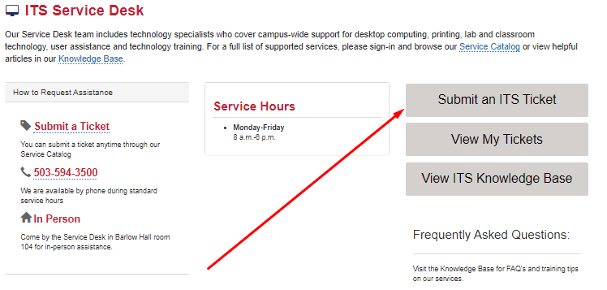

From the Services column, select the Laptop and Chromebook Support tab (please use this option for desktops as well).
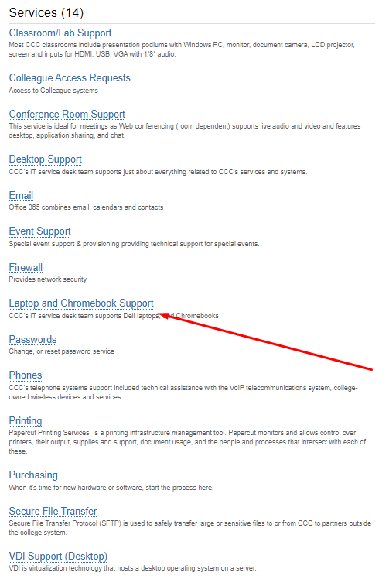
Click the request support button to the right, and complete the fields presented. In the Short Description, please list “Direct Access for laptop/desktop”. In the Description field, please list your workstation name, room number/department, and your name.
*(Your workstation name can be located by right clicking the Windows icon in the bottom left corner of your screen and selecting System. Under Device Specifications, locate the Device Name and note)

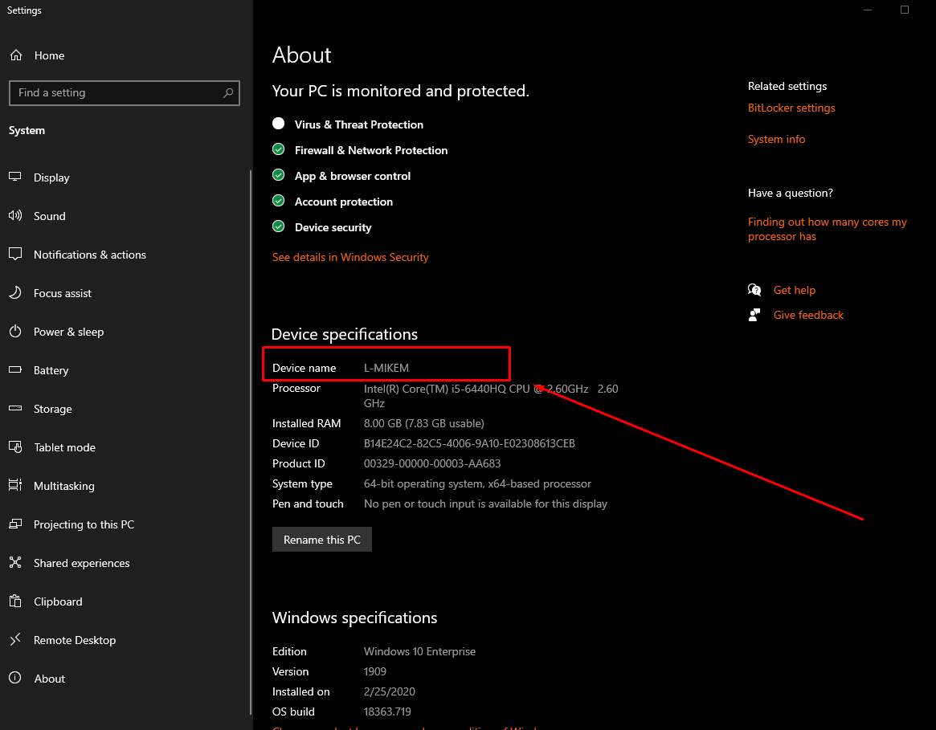

Complete the remaining fields and hit “Request”. Once Submitted, the ITS Help Desk will receive the request to be processed. Once completed, ITS will update the machine’s policy to reflect the new service.
The machine MUST be connected to the College network via cable for this policy to be applied. Machines removed from campus before this happens will not work remotely and will have to be returned to be updated with the new policy.

Procedures for Connecting Remotely

Direct Access
Direct-access enabled devices, when connected to your home Internet, will create a secure connection into the college’s network with no user action required. Your desktop/laptop will function as if you were directly connected to the network via cable at your work location on campus. Network drives will be available shortly after the connection is made, and all files saved there will be available to use.

VDI / Virtual Desktop

Connect using web access
To begin a remote web connection to your Clackamas Community College VDI virtual machine open a web browser such as Edge, Firefox, or Chrome and navigate to https://horizon.clackamas.edu (see Figure 1).
Figure 1. VDI Web access login page
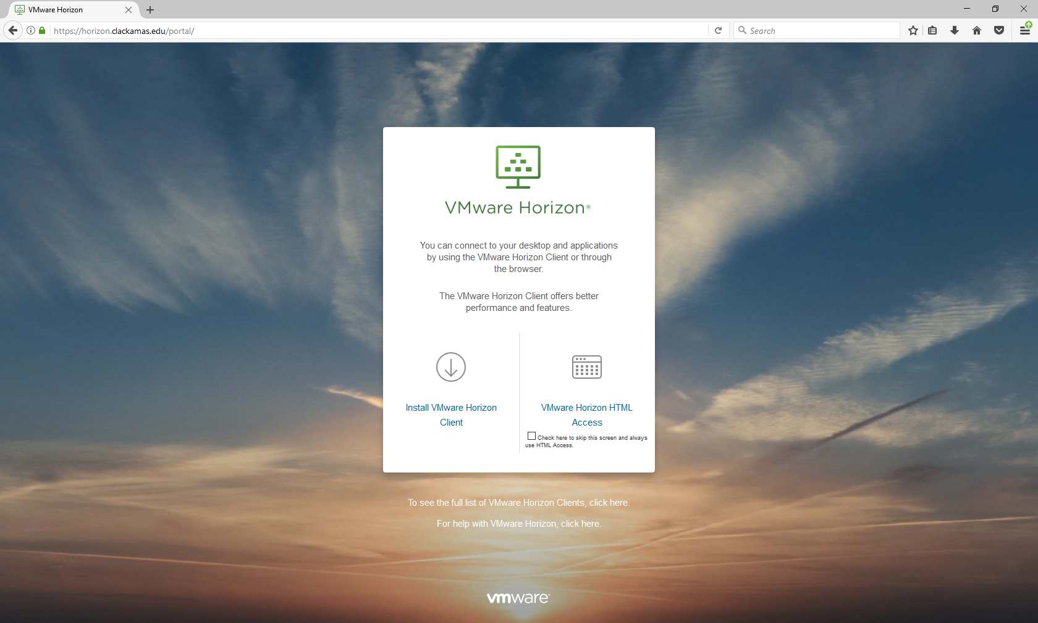

You can choose to either connect to the VDI desktop within the web browser itself or to download the Horizon Client.
The “VMware Horizon HTML Access” option will open the VDI desktop within a webpage. This option is useful when you only occasionally connect to the VDI desktop, or if you do not have permission to install software on the device you are using to connect to the VDI environment.
The “Install VMware Horizon Client” (preferred) option will take you to a VMware webpage to download the appropriate version of the Horizon Client. This installation is a one-time, device specific install, and the subsequent access to the VDI desktop can be had by launching the Horizon Client. This option is useful if you routinely access the VDI desktop from a specific device and you have privileges to install software on the device. The Horizon client software offers more features and better performance.
Table 1 provides additional links to additional VMware resources.
Table 1 Additional VMware resources
HTML Access User Guide | https://docs.vmware.com/en/VMware-Horizon-HTML-Access/4.7/html-access-user.pdf
Windows Horizon Client User Guide | https://docs.vmware.com/en/VMware-Horizon-Client-for-Windows/4.6/horizon-client-windows-desktop-46-user-guide.pdf
MAC OS X Horizon Client User Guide | https://docs.vmware.com/en/VMware-Horizon-Client-for-Mac/4.0/horizon-client-mac-document.pdf
Android Horizon App User Guide | https://docs.vmware.com/en/VMware-Horizon-Client-for-Android/4.7/horizon-client-android-user.pdf
iOS Horizon Client User Guide | https://docs.vmware.com/en/VMware-Horizon-Client-for-iOS/4.6/horizon-client-ios-46-user-guide.pdf

Accessing the VDI virtual desktop using VMware Horizon HTML Access
To access your Clackamas Community College VDI virtual machine using a web browser open a web browser and navigate to https://horizon.clackamas.edu and select the “VMware Horizon HTML Access” link, shown in Figure 2. The “Check here to skip this screen and always use HTML Access” can be checked to prevent this screen from showing in the future, useful if you will only use HTML access.

Figure 2 VDI Web Browser Access Link
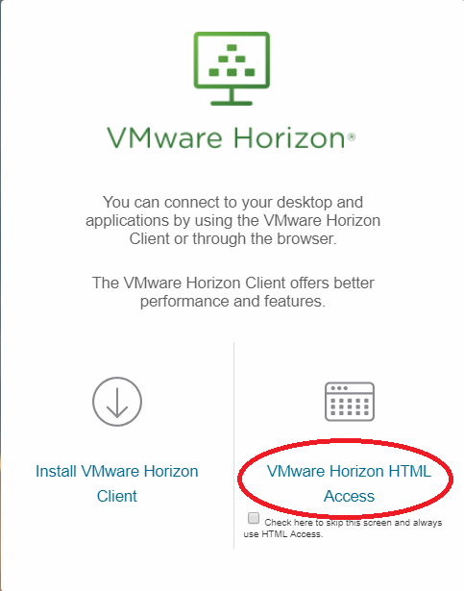
On the next screen, shown in Figure 3, enter your username and password. This is the same username and password used to access other Clackamas Community College resources, such as the MyClackamas web portal, or desktop computer. Then select the appropriate domain, (generally Clackamas), and finally click the “Login” button.
Figure 3. VDI Web Browser Login Screen
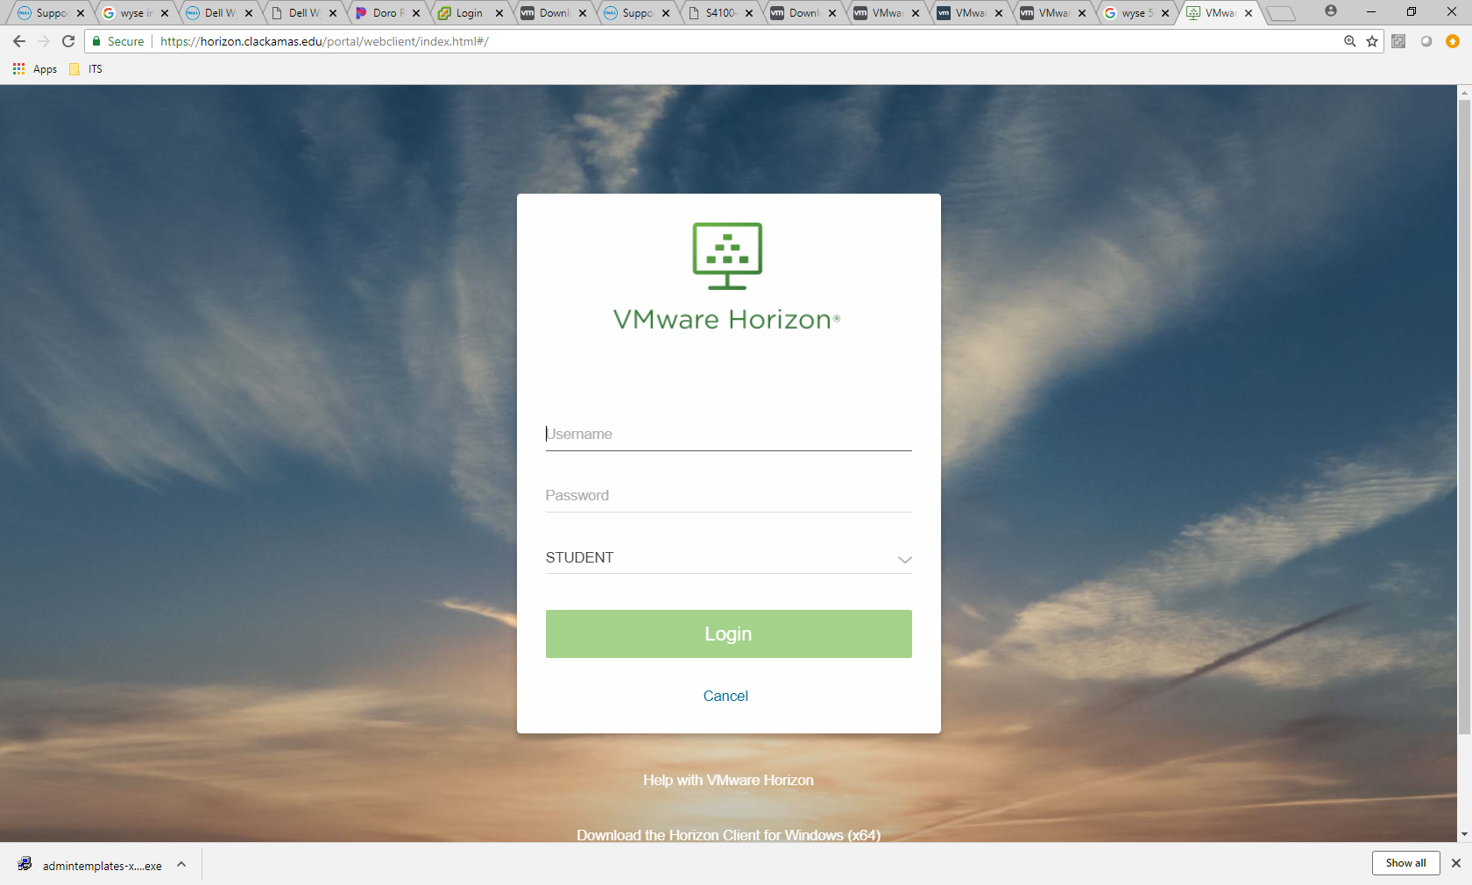

After successful login you may see one or more icons on the following webpage, similar to the one shown in Figure 4. Each icon represents a Clackamas Community College VDI virtual machine or application. If you have more than one visible item and are unsure which is your VDI desktop contact the ITS department for instruction on which desktop you will connect to; typically this will be an option with “WINDOWS 10”.Click the appropriate icon to connect to your VDI virtual machine.
Figure 4. VDI Web desktop selection
After selecting your VDI virtual machine you will be prompted with a security warning. The warning is expected and is the result of the virtual machine’s self-signed certificate, accepting the warning will not put your information at risk. The steps to proceed past the warning page will vary based upon which browser and browser version is used to make the connection. Examples from several browsers follow on the next pages.
Google Chrome

Click “Advanced”
Click “Proceed to 10.161.x.x (unsafe)”

Mozilla Firefox
Click “Advanced”

Click “Add Exception”

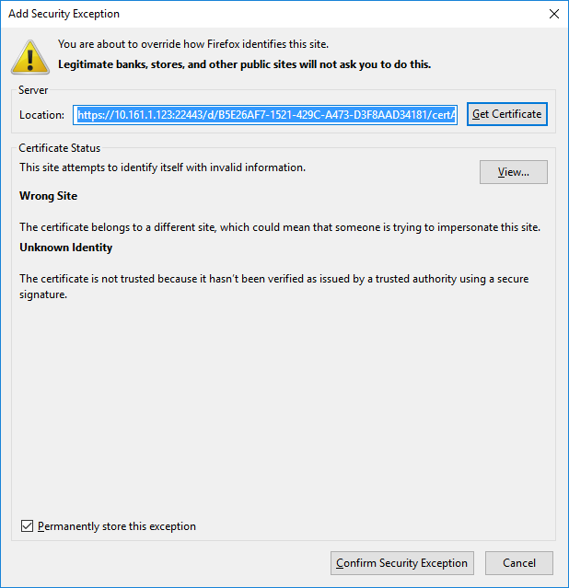
Click “Confirm Security Exception” in the pop-up window

Microsoft Internet Explorer
*NOTE* Clackamas Community College computers are not configured to allow connections using Internet Explorer, instead use the Horizon Client or another browser.
If connecting using IE off-campus: Click “Continue to this website (not recommended)”

Microsoft Edge
Click “Continue to this website (not recommended)”

After accepting the security warning, you will be connected to the selected virtual machine. Refer to Chapter 3 of this publication for additional information regarding the use of your Clackamas Community College VDI virtual desktop.

Disconnect from VMware Horizon HTML Access
Before disconnecting it is important to save your work. The VM may remain running while you are disconnected but saving is the only sure way to ensure that work will not be lost.
You can logoff using the options presented by the typical operating system start menu options.
Alternatively expand the Horizon sidebar by clicking on the tab located on the left edge of the window, refer to Figure 5.

Figure 5 HTML Sidebar Tab location
Inside the sidebar click the menu button next to the “Running” virtual machine to expand, then select either the “Log off” or “Close” options, refer to Figures 6 and 7 “Log off" will close running application and documents. “Close” will allow running items to continue running, although it is still best practice to save items before disconnecting.
After selecting an option you will be see a warning window to confirm the action. Click “OK” to close your virtual machine. Click “Close” in the next window confirming that you have been disconnected.
Logout of the Clackamas Community College Horizon webpage by expanding the menu in the upper left of the page, as shown in Figure 8 and selecting the “Log out” option, then click OK in the confirmation window.
Figure 6 HTML Virtual Machine disconnect menu
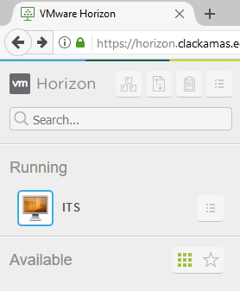
Figure 7 HTML disconnect menu options

Figure 8 HTML Logoff
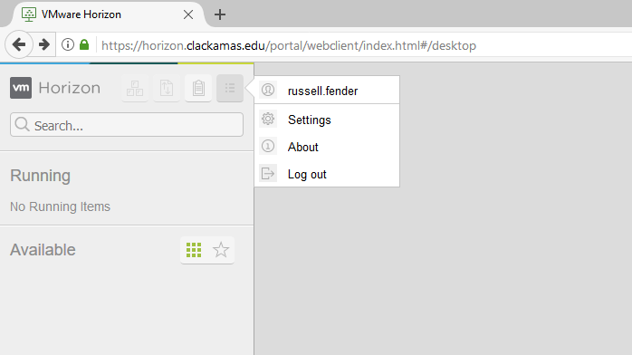

Connect using the VMware Horizon Client
The VMware Horizon Client is a program that is locally installed on the local computer. The client must first be downloaded from VMware’s website and installed. After installation the client can be launched directly without additional downloads.

Installing the VMware Horizon Client

To access your Clackamas Community College VDI virtual machine using the VMware Horizon Client the client must first be downloaded and installed on your device. Open a web browser and navigate to https://horizon.clackamas.edu and select the “VMware Horizon HTML Access” link, shown in Figure 9

Figure 9 VDI Client Access Link
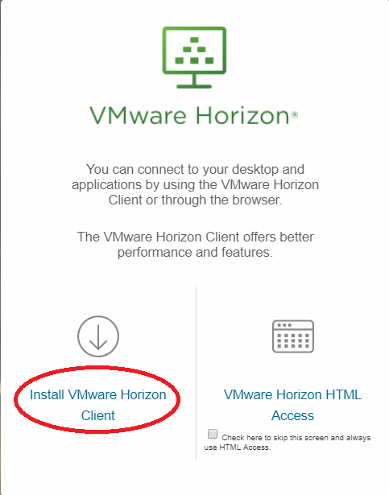

Clicking the link will navigate to a VMware page, similar to the one shown in Figure 10, where the VMware Horizon Client can be downloaded for a variety of different platforms.
Figure 10 VMware Horizon Client platform selection page
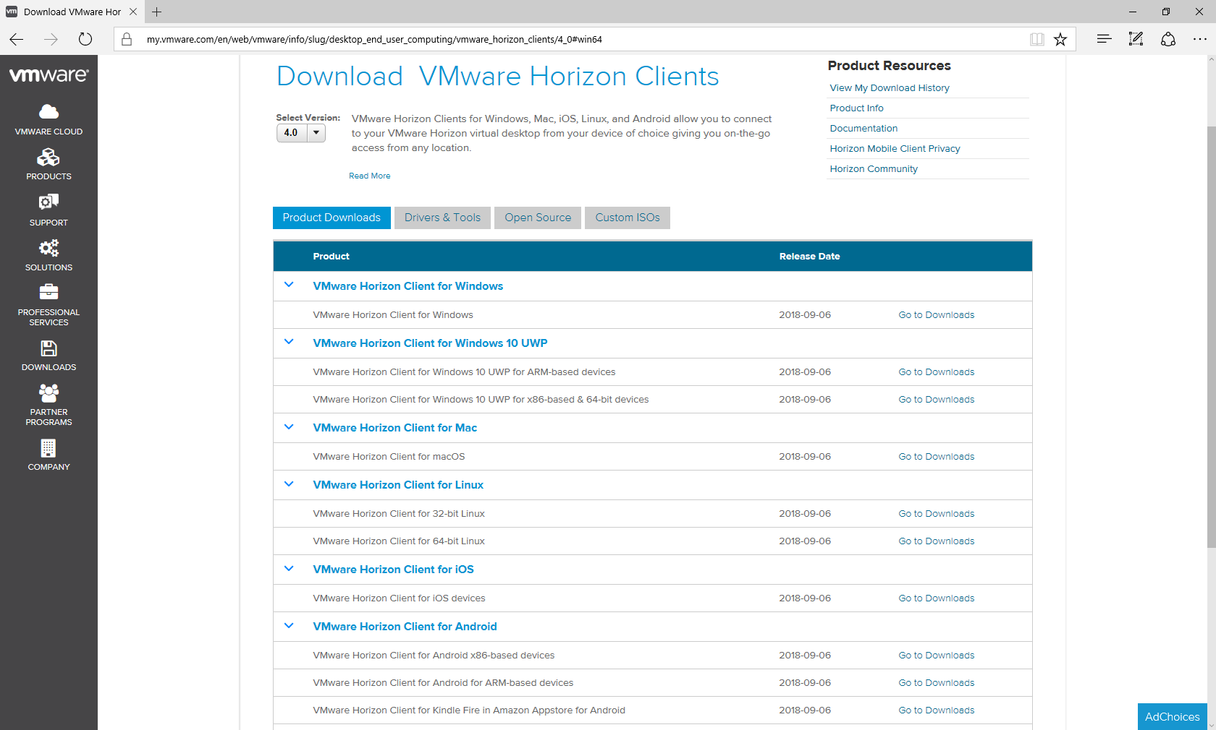
Click on the “Go to Downloads” link next to the client applicable to your platform, and on the next page click the “Download” button as shown in Figure 11

Figure 11 VMware Horizon Client download page
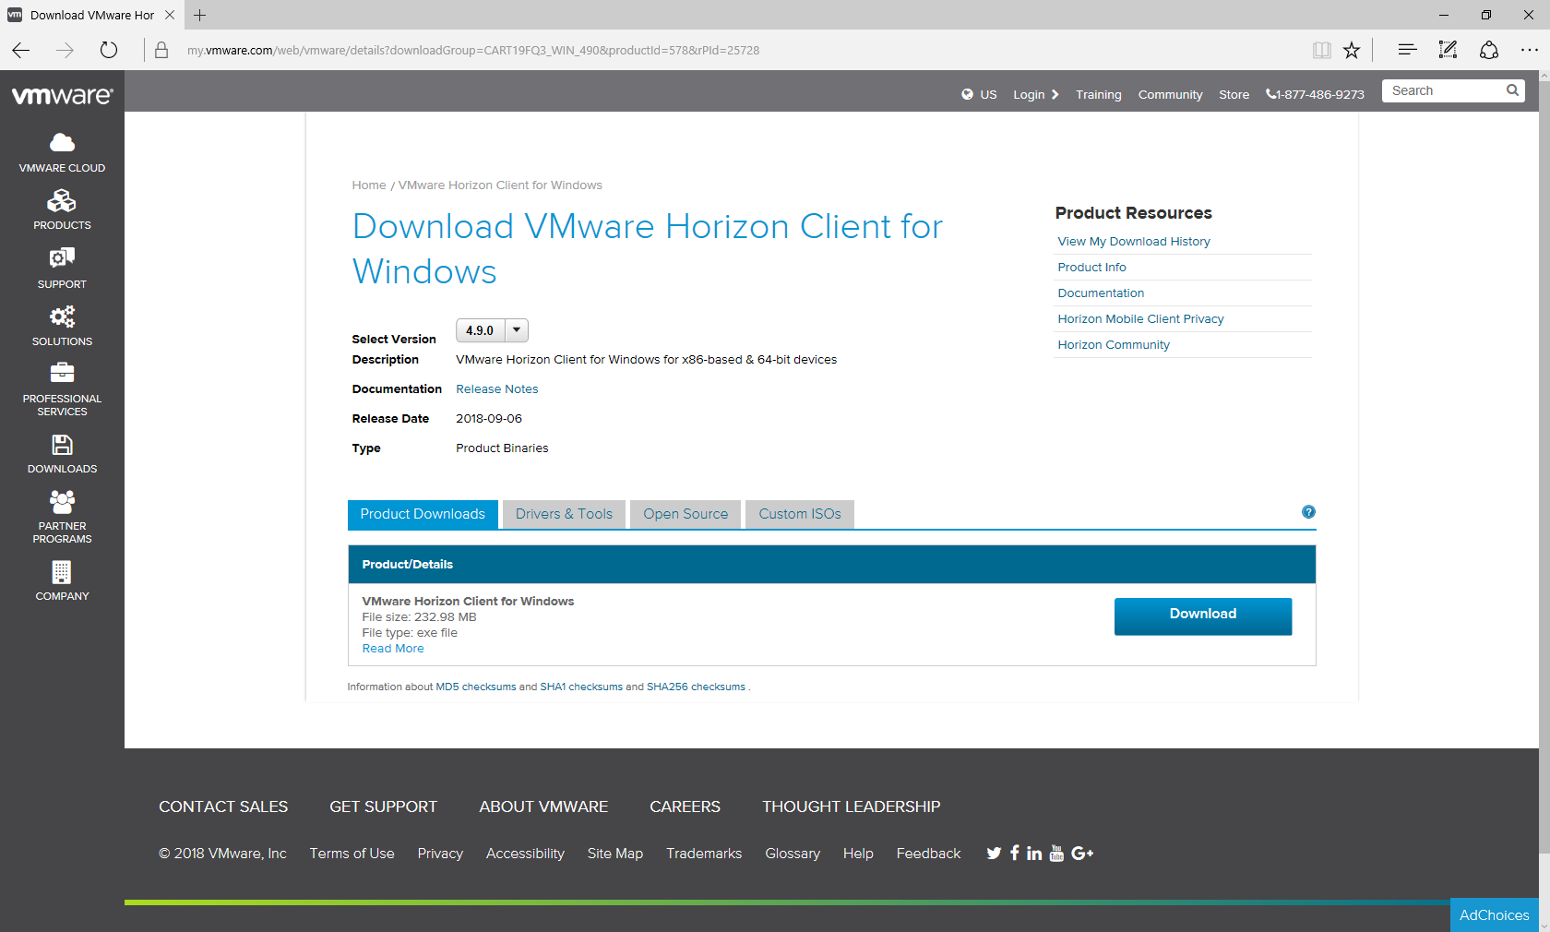
Install the client using the installation procedures for your specific computing platform. The VMware Horizon Client software is provided by VMware and is not warrantied or guaranteed by Clackamas Community College. If additional assistance is needed with the installation, usage, or removal of the VMware Horizon Client please refer to the user guides referenced in Table 1 of this publication.

Using the VMware Horizon Client
Launch the VMware Horizon Client, you should be presented with a screen similar to the one shown in Figure 12. If this is the first time using the client you may need to provide server connection settings. If the VMware Horizon Client shows “Add Server” as shown in Figure 13, then add the server by double clicking the “Add Server” icon, and in the next window enter: Horizon.Clackamas.edu, then click Connect; refer to Figure 14.
Figure 12 VMware Horizon Client Server selection screen

Figure 13 Add Server to VMware Horizon Client
Figure 14 Enter Server Information
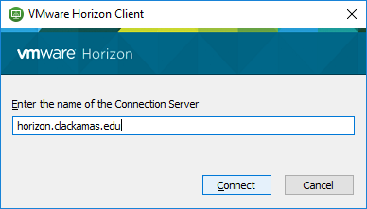
The next screen, Figure 15, will prompt you to enter your User name and Password. This is the same as the Username and Password used to access other Clackamas Community College resources, such as the MyClackamas web portal.

Figure 15 Login Screen
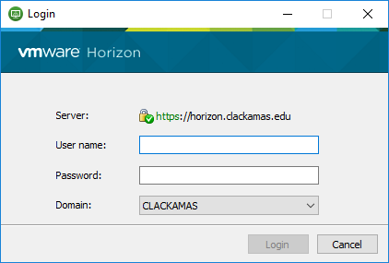
The next screen, similar to the one shown in Figure 16, displays one or more icons. Each icon represents a Clackamas Community College VDI virtual machine or application. If you have more than one visible item and are unsure which is your VDI desktop contact the ITS department for instruction on which desktop you will connect to; typically this will be an option with “WINDOWS 10”. Double click the appropriate icon to connect to your VDI virtual machine.
Figure 16 VMware Horizon Client desktop selection screen
You may be prompted upon connection to share locally connected storage devices with the virtual machine. The prompt will appear similar to the one shown in Figure 17. Select “Allow” if you wish to be able to move files between your local device and the virtual computer. Click “Deny” to prohibit this behavior. Check the “Do not show this dialog again” if you do not want to be prompted to make this choice every time you connect using the VMware Horizon Client.

Figure 17 File Sharing Prompt

Disconnecting the VMware Horizon Client
Before disconnecting it is important to save your work. The VM may remain running while you are disconnected but saving is the only sure way to ensure that work will not be lost.
You can Logoff using the options presented by the typical operating system start menu options.
Alternatively, expand “Options” menu located on the connection toolbar, normally located in the top center of the main screen (you may need to hover over the area for a few seconds if the toolbar is unpinned.) From this menu select either the “Disconnect” or “Disconnect and Log Off”, refer to Figure 18.
“Disconnect and Log Off" will close running application and documents. “Disconnect” will allow running items to continue running, although it is still best practice to save items before disconnecting.
Sign out of the Clackamas VDI server by clicking the “Unplug” icon in the upper left corner, refer to Figure 19. Select yes to confirm, then close the window.
Figure 18 Disconnect using the Connection Toolbar
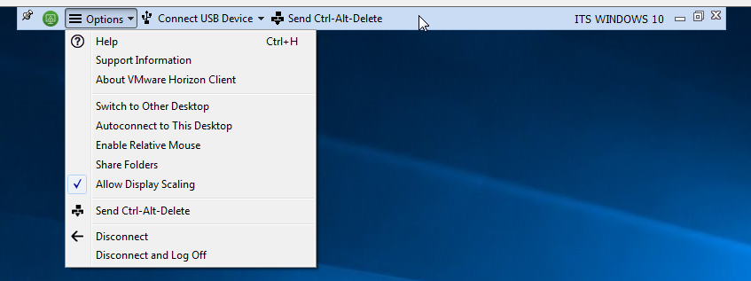

Figure 19 Horizon Client sign out
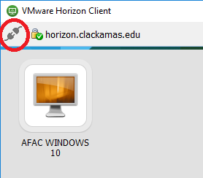

ITS Remote Support
The ITS Help Desk is available to provide support to all college remote users via the normal Help Desk contact number (503-594-3500) and via the Service Desk ticketing system. Support is limited to college-owned desktops/laptops/mobile devices and applications provided by the college for normal use. We are unable to provide remote support for internet service provider issues and non-college devices.

https://docs.vmware.com/en/VMware-Horizon-HTML-Access/4.7/html-access-user.pdf, page 4, accessed 9/28/2018
Web URLS current as of 9/28/2018, web addresses can change at any time, If the link fails to work use a web browser to search for the document title

